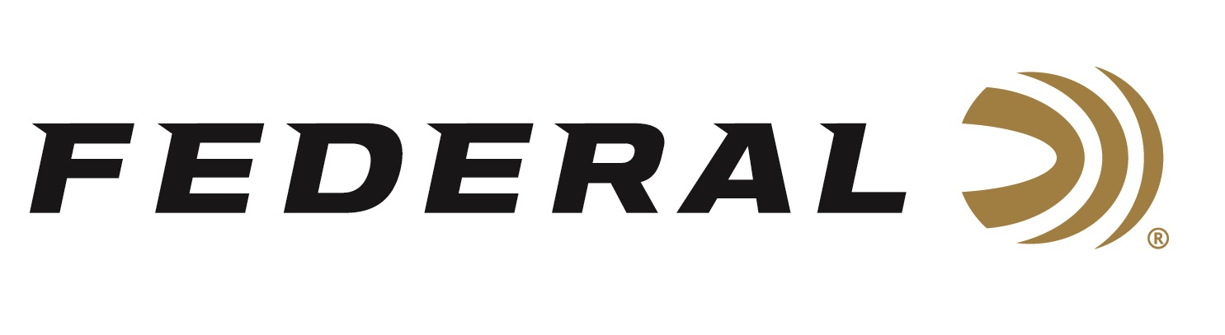

FOR IMMEDIATE RELEASE

Team Federal’s Vincent Hancock Wins U.S. Nationals in Men’s Skeet

ANOKA, Minnesota – May 26, 2026 – Four-time Olympic Gold medalist Vincent Hancock is another step closer to competing for a record fifth gold medal in Men’s Skeet in Los Angeles in 2028. Hancock was victorious at the 2026 Shotgun National Championships in Men’s Skeet. The event was held May 16-20, 2026, at Hillsdale College in Hillsdale, Michigan.

In a new format, eight shooters qualified for the finals including Federal’s Hancock and Conner Prince. Hancock, coming into the finals with the #1 bib, would break all 36 targets presented to win by one over Christian Elliot, representing the U.S. Army Marksmanship Unit. “It was a tough competition this week with the weather and a stacked field of athletes. I had to fight hard to shoot as well as I did and I’m incredibly thankful to have won the USAS National Championship again,” said Vincent Hancock, 4-time Olympic gold medalist.

Hancock previously won the National Championship in Men’s Skeet in 2023 and was a silver medalist in 2025. “Thank you to Federal for supporting this journey and ensuring that I'm always working with the best equipment and gear possible,” said Hancock. Conner Prince finished the championship in eighth place. Both Hancock and Prince qualified for a place on the Men’s Skeet National Team for the U.S.A.

In the Women’s Skeet National Championship, former Olympic Champion Amber English finished the event with a bronze medal. English, who won gold in Tokyo, shot extremely well against a deep field of the best skeet shooters in the world. English was named to the USA Women’s Skeet Development team.

Federal Ammunition products are available at dealers nationwide and online. For more information on all Federal products and to sign up to receive notifications about new product availability, rebate promotions, and other brand news via email, visit www.federalpremium.com.

Press Release Contact: JJ Reich
Senior Manager – Press Relations
E-mail: media@tkghunt.com

About Federal Ammunition
Federal, headquartered in Anoka, MN, is an ammunition brand of The Kinetic Group, owned by CSG, a globally diversified industrial group based in Prague, Czech Republic. Since 1922, Federal has been a leader in ammunition innovation, delivering high-quality sporting and hunting products to shooters worldwide. With a commitment to conservation and the outdoor community, Federal continues to manufacture industry-leading ammunition that enhances the shooting experience while supporting outdoor traditions.

